Maine Cheese Guild Testimony on Amending LD725 (October 20, 2017)
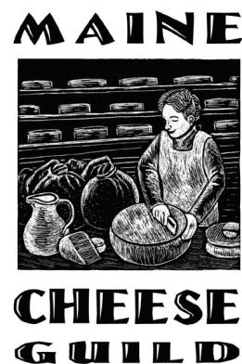
Senator Davis, Representative Martin, members of the Joint Legislative Committee on State and Local Government, and members of the public, thank you for the opportunity to speak in this forum. My name is Jessie Dowling, President of the Maine Cheese Guild. On behalf of the Guild I would like to testify FOR Amending LD725 in such a way that Maine can continue its Meat and Poultry State Licensing program.

There are many problems the Maine Cheese Guild has with LD725 that we hope can be improved in non-Emergency legislative session, but right now it is most important for this committee and at least two thirds of the Legislature to amend the bill so that the Federal Government does not cancel Maine’s contract to offer State Inspection of its meat and poultry processors.

It may seem odd that cheese makers are concerned about the fate of the meat and dairy inspection program, but all dairy comes from livestock, and meat production is a necessary by-product of any dairy farm. Many of Maine’s small dairy producers depend on income from selling meat as well as their dairy products. Maine is one of a few states with a State Inspection program when it comes to meat and poultry, and that is a key element to the growth and vitality of Maine’s small farms.

If Maine were to lose our State Inspection authority for meat and poultry, almost all of the existing slaughterhouses that Maine meat producers depend on would be closed AND any existing State Inspected meat and/or poultry products that Maine small farmers had counted on selling would have to be pulled from the marketplace after a short period of time. Both of those would be devastating to Maine’s meat and dairy producers alike. We cannot let this happen.

That is why the Maine Cheese Guild supports amending LD725 to prevent the Federal takeover of our meat inspection. And unfortunately this must be done during this emergency session.

If you care about consumers being able to have access to locally raised and processed meat throughout the state in our farmers markets and retail stores, then you will support amending LD725.

Thank you for your time

